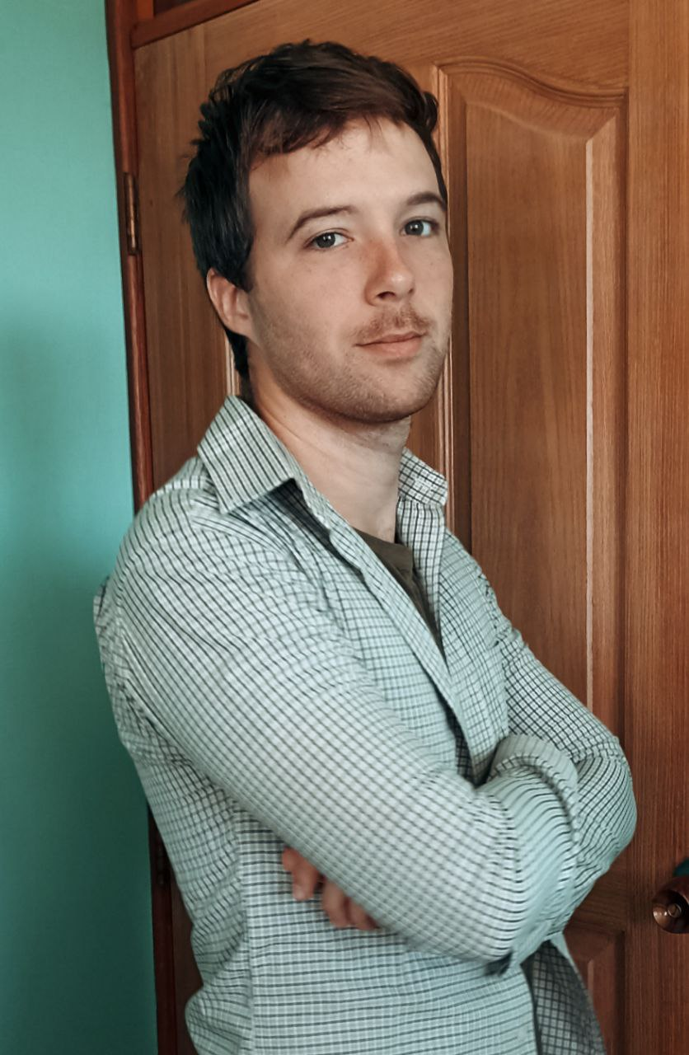

**Frontend Developer Flutter/Dart**

**Jesús Hernández**

**DIPLOMAS Y HOBBIES**

**Formaciones :** Diplomados, Congresos, xxxxxxxxxx xxxxxx xxxxxxxxx xxxxxxxxxxxxxxxxx

**Hobbies:** xxxxxxxxxxxxxxxxxxxxxxxxxxxxxx



Software developer dedicated to producing high-quality, readable, well-documented, and functional code. Always looking for the next project or challenge that will help improve my training and performance.

Software development enthusiast, with experience in Flutter since it was in its Beta version.



+53 5 426 8660 jhernandezb96@gmail.com Havana, Cuba



State Management:

* Get
* Bloc
* Provider
* Riverpod

Databases:

* ObjectBox
* Rive
* Moor
* SQLite

Version Control:

* GIT
* GitKraken GUI
* GitHub
* Bitbucket

Third party api:

* Dio
* Retrofit
* Get
* http

**PROFESSIONAL EXPERIENCE**

**LANGUAGES**

09/2023 – 07/2024

(Havana - Cuba)

01/2022 – 09/2023

(Havana - Cuba)

**Zyrcled**

Frontend developer

Achievements / Tasks:

* Development of **Android** and **iOS** applications using **Flutter**.
* Integration with Google/Firebase services: **Firestore**, **FCM**, **Authentication**, **Storage**, **Maps** and **Crashlytics**.
* Integration with **Supabase** services, with a focus on user management and **PostgreSQL** with its realtime work.
* Use of modular architectures using **Melo** for better organization and scalability.
* Consumption of **third-party APIs** and integration with **Cloud Functions**, as well as the internal backend.
* Application of **realtime** techniques and work with **Stream** to ensure an effective updating of data.
* Development of **dating-apps** type applications with a strong social sense and high volume of traffic.
* Collaboration in multiple community packages such as: [**feedback**](https://github.com/ueman/feedback/pull/293)**,** [**flutter_zoom_drawer**](https://github.com/medyas/flutter_zoom_drawer/issues/67)**,** [**circular_countdown_timer**](https://github.com/MuhammadUsamaSiddiqui/circular_countdown_timer/pull/35)**,** [**custom_dropdown**](https://github.com/AbdullahChauhan/custom-dropdown/pull/20)**.**

**TuVendor**

Frontend developer

Achievements / Tasks:

* Interpretation of **UI/UX** designs made in **Figma** and adaptation of them to the visual of the application.
* Analysis of user requirements and translation of customer needs into **iOS** and **Android** application designs.
* Development of **e-commerce**, **services**, **news** and **transportation** applications.
* Use of various architectures such as **Clean** and **MVVM**, and state managers such as **Get**, **Bloc/Cubit** and **Provider**.
* Use of version control systems (GitKraken and **GitHub**).
* Consumption of **Rest** and **GraphQL** APIs.
* Integration with payment gateways such as **Stripe** and **Tropipay**.

Spanish:

English:

Hebrew**:**

[](https://stackoverflow.com/users/11643193/jesus-hernandez-barrios)[](https://github.com/JesusHdez960717/JesusHdez960717)[](https://stackoverflow.com/users/11643193/jesus-hernandez-barrios)[](https://github.com/JesusHdez960717/JesusHdez960717)

jesus-hernandez-barrios

Root101

JesusHdez960717

**SOCIAL**

@jhernandezb96

**Jessica A. García**

Root101 | Co-Owner

Phone +53 5 824 1170

[jgarciaalbalah](mailto:jgarciaalbalah@gmail.com)@gmail.com

**Mayling Mirabal**

CITMATEL | Proyect Manager

Phone +53 5 994 1059

**REFERENCES**

2016 - 2022

Computer Engineering

Technological University of Havana "José Antonio Echeverría"

Havana, Cuba

**STUDIES**